Application number:
(for office use only)
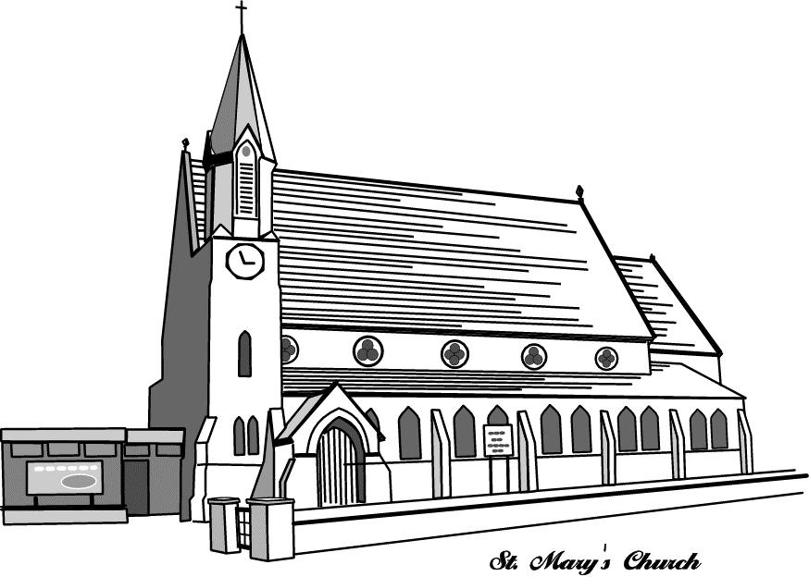

St Mary’s Church, Parish of Beeston
Town Street, Beeston, Leeds LS11 8PN

Job application form
Community and Volunteer Developer
Please return completed form to: revlcp@btinternet.com by 22nd April 2022
The Disability Discrimination Act (1995) defines a disabled person as a person with 'a physical or mental impairment, which has a substantial and long term adverse effect on a person’s ability to carry out normal day to day activities’. You no longer have to be registered disabled.
Do you consider yourself to be disabled? YES/NO
If Yes: What adjustments do you consider may be necessary in the recruitment process to take account of your disability? Are there any arrangements we can make for you if you are invited for interview? Please specify, e.g. the provision of an accessible interview location or an interpreter, aids, adaptations or equipment.
PERSONAL DETAILS
Title: Forenames: Surname:
Address:

Telephone:
Email:
Education and work, including voluntary
Please list your qualifications and work record. Please give dates and say whether positions were paid or voluntary.
The person specification indicates the types of knowledge, skills and experiences that are needed to carry out this position. Please use the space below to demonstrate your knowledge, skills and experience in the areas outlined in the person specification. You may include details of other paid/unpaid work, and any relevant hobbies etc. You may use a continuation sheet if necessary but please keep this to one additional sheet only.
References
Please give names and addresses of two referees. They should be people who know you well but aren’t related to you. Please try and include a former employer.
Referee 1
Name:
Address:
Telephone:
Email:
Occupation:
How do they know you and for how long:
May we approach this referee prior to interview: YES/NO

Referee 2
Name:
Address:
Telephone:
Email:
Occupation:
How do they know you and for how long:
May we approach this referee prior to interview: YES/NO

Please tell us how you heard about this vacancy:
Criminal Convictions
Self-Disclosure Form - Posts exempt from the rehabilitation of offenders act.
St. Mary’s is committed to all aspects of safeguarding. We believe that all children and adults at risk of harm have the right to be protected from abuse. St. Mary’s aims to ensure that all staff, paid or voluntary, seeking to work at St. Mary’s and who have access to children and adults are safe to do so.
If the post for which you are applying for is exempt from the provisions of Section 4(2) of the Rehabilitation of Offenders Act 1974, by virtue of the Rehabilitation of Offenders Act 1974 (Exceptions) Order 1975 (as amended in 2013 and 2020), you are not entitled to withhold information about convictions, cautions, reprimands or final warnings that are not 'protected', i.e. those which are for other purposes 'spent' under the provisions of the Act, but for this purpose would not be filtered in line with current guidance. The amendments to the Exceptions Orders provide that when applying for certain jobs and activities, certain 'spent' convictions and cautions are 'protected' and are not subject to disclosure to employers, and cannot be taken into account even if they are disclosed.
Guidance and criteria on filtering can be found on the Disclosure and Barring Service website. https://www.gov.uk/government/publications/dbs-filtering-guidance It is your responsibility to read this information in full and complete the application form accurately.
If you fail to disclose that you have been convicted of a criminal offence or received a caution, reprimand or warning this may lead to dismissal or disciplinary action by St. Mary’s. Any information given will be treated in the strictest confidence and will be considered only in relation to an application for which the order applies. For jobs that are subject to a disclosure, please note that a criminal record will not necessarily bar you from employment. This will depend on the nature of the position you are applying for and the circumstances and background of the offence.
You may be offered the job subject to satisfactory pre-employment checks which can include obtaining an Enhanced DBS disclosure certificate. This intensive procedure can take some time; however, we ask that you appreciate the reasons why such stringent checks are made, and bear with us whilst they are completed.
Do you have any unspent conditional cautions or convictions? YES/NO
If Yes, please provide details:
Do you have any adult cautions (simple or conditional) or spent convictions that are not ‘protected’ as defined by the Exceptions Orders? (You do not need to disclose reprimands, final warnings or youth cautions, or anything that would be filtered by the DBS) YES/NO
If Yes, please give details:

Are there any other relevant matters pending? YES/NO
If ‘Yes’ please give details

DISCLOSURE OF INFORMATION
Please sign and date below to indicate your agreement to the following declarations which applies to all information provided by you in this application.
DATA PROTECTION ACT
I give my explicit consent for the personal and special category data contained in this Application Form to be processed for the purposes of this recruitment process..

DECLARATION
I declare that the information I have given on this form is complete and accurate and that I am not barred or disqualified from working with children and / or vulnerable adults nor subject to any sanctions or conditions on my employment imposed by a regulatory body or the Disclosure and Barring Service. I understand that to knowingly give false information, or to omit information, could result in the withdrawal of any offer of appointment, or my summary dismissal at any time in the future. I provide consent for the DBS Team to undertake an external validation check, if identification has been provided via Route Two of the DBS process.
Signature: Date:

Shortlisting will only take place after closing date.

We thank you for your interest shown in working for St. Mary’s.

